ANNUAL BLESSING OF THE ANIMALS
On Sunday, October 4, 2026 at 9:00AM, Father Jose will perform the annual “Blessing of the Animals”on the front steps of the Church.
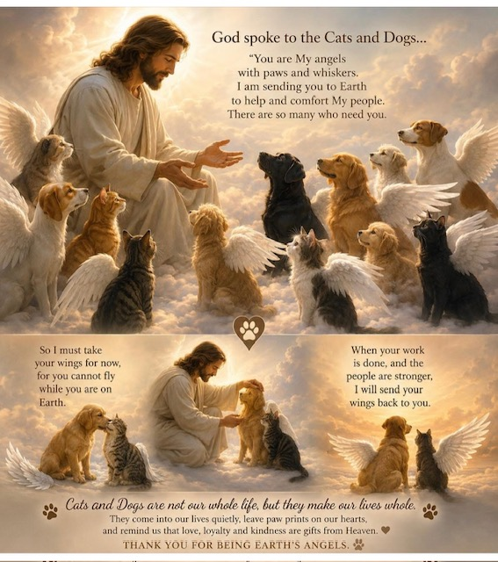
All are welcome to participate.

